Analogous Experiences
Step 1:
Choose a piece of the service, experience, or problem you want to focus on.
The decision-making moment when a young adult chooses what to invest in.
Step 2:
Identify one emotion you want to evoke in your audience of focus.
Safety.
Step 3:
Brainstorm other services, experiences, or solutions that evoke that emotion.
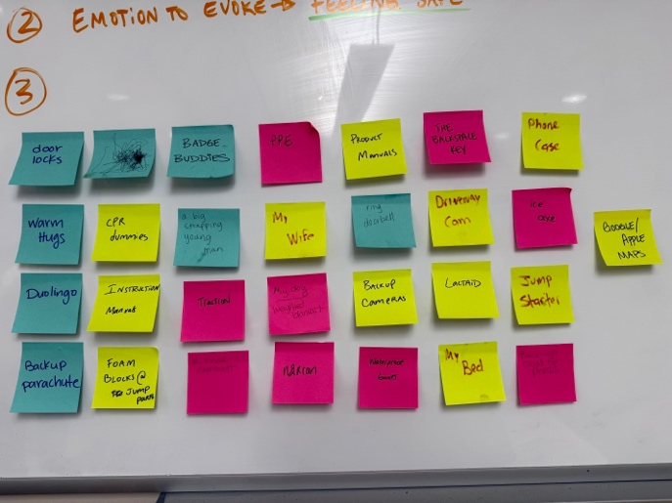
Choose one to move forward with.
Ring Doorbell.
Step 4:
Explore how that analogous service, experience, or solution evokes that emotion. Get specific.
Ring Doorbells evoke a feeling of safety through several specific mechanisms. They provide real-time monitoring, allowing users to check on their environment at any moment. They offer instant alerts when unusual activity is detected, reducing uncertainty and preventing harm before it occurs. Ring also records past events, enabling users to review what happened and understand situations after the fact. Lastly, the system offers control without requiring constant attention, users can “check in” when they want, rather than constantly worrying.
Together, these features reduce anxiety, increase perceived control, and create a sense of protection even in uncertain or unfamiliar situations.
Due to participant energy constraints, this portion of the exercise was completed through a guided verbal discussion rather than the physical activity. I later transcribed and organized the group’s ideas onto sticky notes.
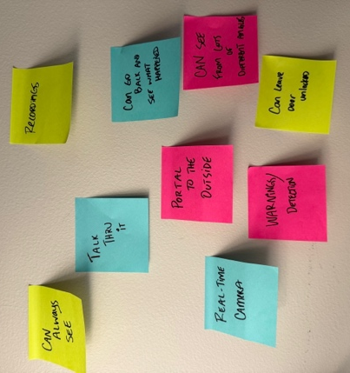
Step 5:
Fill in this madlib statement: How might we make (our service, experience, or problem) more like (analogous service, experience, or solution)?
How might we make choosing investments feel as safe and reassuring as using a Ring Doorbell?
Step 6:
Use this madlib as the framing for a second brainstorm to generate new ideas for your context.
This question was used as the framing for a second round of concept generation. Participants were prompted to imagine what it would look like if the experience of choosing investments had similar qualities to a Ring Doorbell, such as real-time monitoring, alerts, recorded history, shared access, and passive reassurance.
At this point in the session, participant energy had decreased, which resulted in more fragmented ideas and a smaller amount of ideas overall. I later interpreted, expanded, and clarified these ideas by mapping them directly to specific Ring Doorbell features. This translation step allowed the early fragments to become more concrete, actionable concepts.
The following ideas were generated from this second brainstorm:
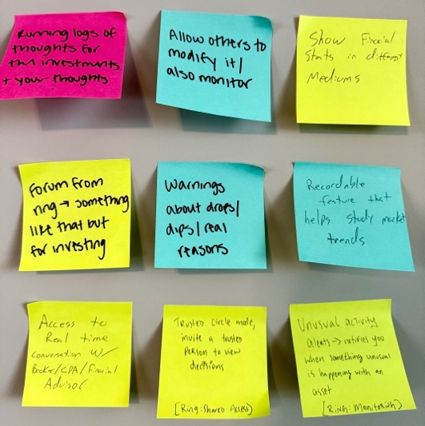
Running logs of thoughts for the investments and your thoughts Event history + video playback. Investing version: Like a decision journal timeline that records what the user chose, when they chose it, and what they were thinking at the time.
Allow others to modify and monitor shared device access. Investing version: A trusted circle mode where users can invite a friend/partner/mentor to view decisions, leave comments, or help flag risky actions, etc.
Show financial stats in different mediums Visual and notification-based feedback. Investing version: multiple representations of financial data: simple visuals, color-coded risk meters, audio explanations, or short summaries instead of dense charts.
Forum from Ring, something like that but for investing Neighborhood/community feed. Investing version: a community reassurance feed where users can see what others are experiencing, normalize mistakes, and share learning moments.
Warnings about drops, dips, real reasons Motion alerts. Investing version: plain-language notifications that explain why something is happening.
Recordable feature that helps study market trends recorded clips + event history. Investing version: A market playback feature that lets users replay what happened over time and understand cause and effect.
Access to real-time conversation with a financial advisor Two-way talk. Investing version: a real-time chat where users can ask questions, feel safe during possibly high-stake decisions.

